***Submission:***

• *Email instructor or TA if there are any questions. You cannot look at others’ solutions or use others’ solutions, however, you can discuss it with each other. Plagiarism will be dealt with according to the course policy.*

*• Submission after due time will not be accepted.*

**Follow this naming convention for your report   
Roll#_Assignment#.pdf e.g BSSE23000_Assignment2.pdf.**

In this assignment you have to do following tasks :

**Task 1:** Sign in to you Github account.  (<https://github.com/signup>)

**Task 2:** Accept Assignment posted in Google Classroom and after accepting clone the repository to your computer for this ensure you have logged into github app with your account.

**Task 3:** Open draw.io from browser to draw flowcharts. ( https://app.diagrams.net/)

**Task 4:** Solve the problems given below using draw.io tool.

**Task 5:** Save your flowcharts in .png format and paste them in word file uncer the corresponding question.

**Task 6:** Paste all flowcharts in Git clone folder.

**Task 7:** Commit the changes through Github App.

**Task 8:** Push the file to the repository.

***Q1. Design a flowchart that calculates the area of a triangle given its base and height. Ensure the flowchart displays both the input values and the area.***

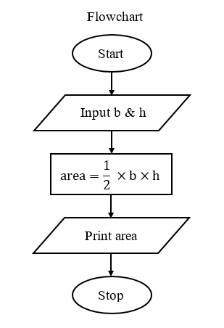

***Q2.*** ***Design a flowchart using Draw.io that outlines the steps involved in setting up and sending an email. Include symbols for decision-making and actions.***

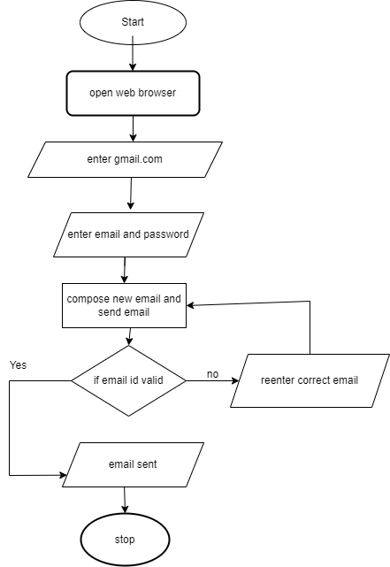

***Q3. Design a flowchart using Draw.io that*** ***take two number x and y as input and exchanges the value of them  The output must be: the value of variable y will become the value of variable x, and vice versa.***

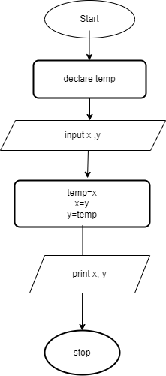

***Q4.*** ***Illustrate a "Student Grading System" flowchart using Draw.io, including input of exam scores and the calculation of final grades***

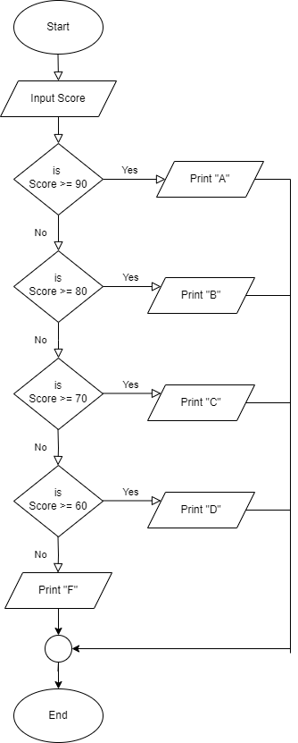

***Q5. Draw a flowchart in Draw.io for the steps required to find the cost of 24 pens when the cost of one pen is Rs. 12.***

